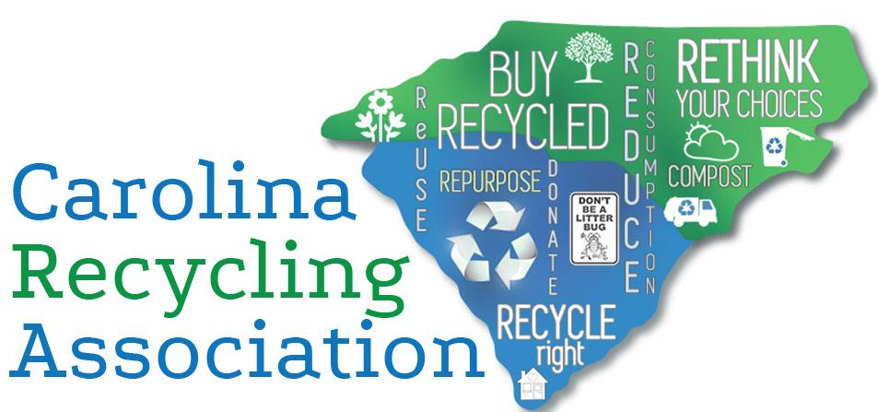

Special Thanks to Our 2019 Sponsors!

Advancing Waste Reduction and Recycling in the Carolinas Since 1989


Top 7 Reasons Recycling Is Here to Stay
Because 7 is the magic number (phone numbers, days of the week, wonders of the world...)

1. Citizens Want To Recycle.
Things are worth what people are willing to pay for them. I'm not talking about grumpy old Mr. Jones that shows up raising cain at the Town Hall meeting every month. I'm talking about the majority of citizens who want to do the right thing and know that recycling is good. Never underestimate the power of getting citizens involved in supporting recycling programs. They just might pay more for it or even save it from imminent doom as they did in Craven County (NC), Greensboro (NC), and Kernersville (NC) earlier this year.

2. Cheap Does Not Equal Better.
One trip to the dollar store will show you that... When we change our mindset about recycling, that it's a utility, similar to power and water, and that it's an essential part of sustainable waste management, suddenly it makes a lot more sense to pay what it really costs for something we need and to work together to share the burden. We can't take for granted that we have very cheap landfill fees compared to other parts of the country, but this will change eventually. Landfill space is finite.

3. Investment.
Like my non-existent stock market portfolio, there are ups and downs with any investment. What's the one piece of advice your broker gives you? Don't divest in a down market! We have made a substantial investment in this system and can weather this period of market adjustment. Unlike other utilities, recycling actually has a chance to recoup costs in the future. And speaking with your dollars by buying recycled content products helps drive demand = markets improve. So buy recycled!

4. Recycling Does Not Exist in a Vacuum.
Sure things might 'suck' at the moment, but that's not because of a vacuum. When you do the math, curbside recycling takes up about twice the volume per ton compared with trash. That means if you put it all in the trash can, you're looking at a MUCH fuller truck, MORE trips to the landfill, ADDING garbage routes, and really FILLING UP landfills at a double rate. That's a no-no and everybody knows it.

5. Change is the Only Constant.
This period of reinvesting in domestic recycling capacity is a great opportunity to teach our citizens that recycling is market-based. It really can't be the "ol' reliable source" of revenue all the time that we all hoped it would be when times were good. It is always evolving and changing, and we should be evolving with it by correcting our expectations of recycling markets and demand for materials.

6. ENVIRONMENT.
Hello!! Recycling remains the easiest activity that large portions of people across the US can do to help the environment. Saving energy, water, land, and natural resources is hugely important to not only humans, but the entire ecosystem. We have GOT to do this for the environment; we heard Greta Thunberg is already talking to her lawyers...

7. Tools.
There are tons of tools, grants, and assistance out there to maximize your recycling program quality and participation! Whether it is #RecycleRightNC, #RecycleRightSC, The Recycling Partnership, the WRAP Program, SERDC, Keep America Beautiful, or CRA, your tool cup should be overflowing. For a list of these resources, visit CRA's resources page.

Thank you for reading, and Happy America Recycles Day!!

